УКРАЇНСЬКИЙ ЖІНОЧИЙ РУХ МАТЕРІ СВІТУ ПРОТИ ВІЙНИ ТА ТЕРРОРИЗМУ | 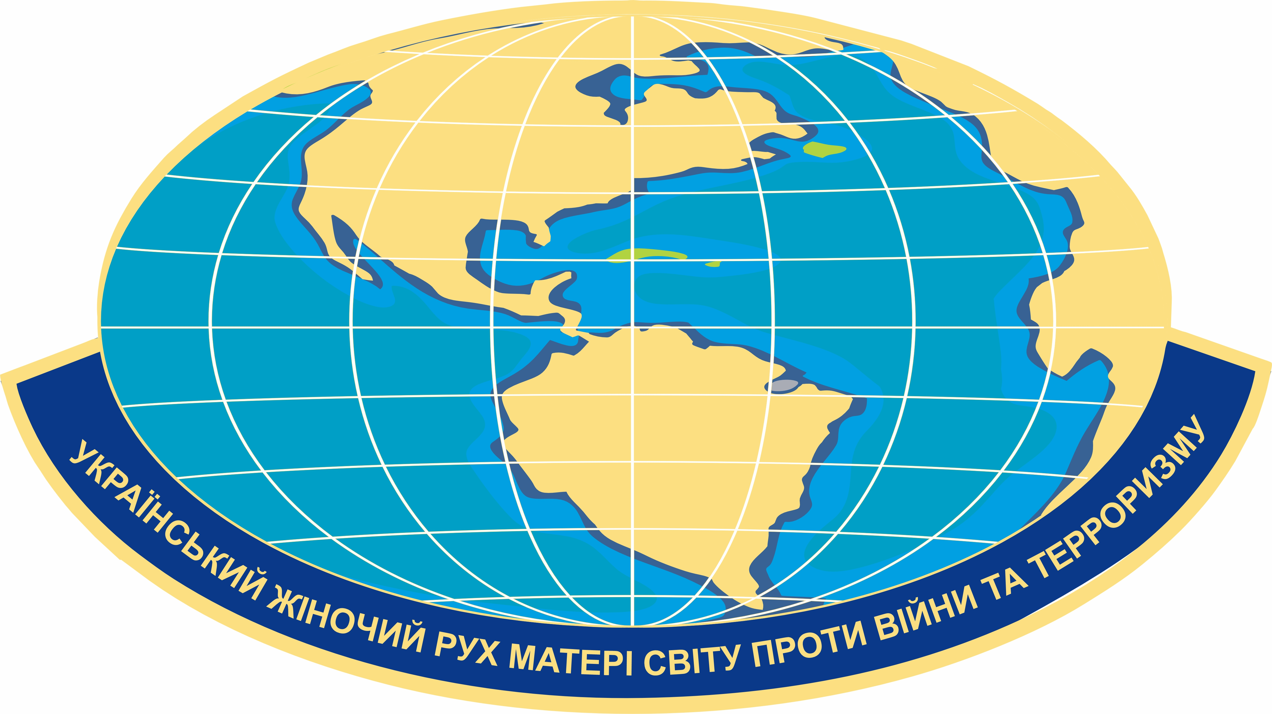 | MOTHER OF THE WORLD UKRAINIAN WOMEN'S MOVEMENT AGAINST WAR AND TERRORISM

р/р - Ua223226690000026006300589972, ЄДРПОУ - 39351325, МФО - 322669
Україна О3О4О м. Київ проспект Голосіївський 87"Л"
www.stolica-ua.com, fondvvv@ukr.net, +38 097-663-47-51 (Viber) +38 050-141-08-76 (WhatsApp)
РІШЕННЯ ЗАСНОВНИКІВ
No. 2-9/24 dated September 30, 2024

1. TO ESTABLISH AN INTERNATIONAL TRIBUNAL FOR JOURNALISTIC INVESTIGATIONS OF WAR CRIMES COMMITTED AGAINST THE INDEPENDENT UKRAINIAN STATE OF UKRAINE WITH THE SAME NAME AND TO MERGE IT WITH THE SECURITY INFORMATION COMMITTEE OF THE UKRAINIAN INTERNATIONAL PRESS SERVICE INTO ONE COMMITTEE - TO APPROVE THE RELEVANT REGULATION.
2. On the basis of the Committee for Legal Assistance for the Protection of the Rights of Mothers and Children Forced to Stay Abroad, develop a project and launch the project “Returning Children Home” together with the Charitable Foundation “America to Ukraine” under the agreement on cooperation and cooperation.
3. TO ESTABLISH AN EDITORIAL BOARD AND PUBLISH THE BOOK “THE SECOND WORLD TRIP OF THE PEOPLE'S DIPLOMACY” IN UKRAINIAN AND ENGLISH FOR THE PURPOSE OF DISTRIBUTION OF THE BOOK “UKRAINIAN SONG ABROAD” IN THE USA AND EUROPE AT THE EXPENSE OF THE CHARITY FUND “AMERICA TO UKRAINE” TO PATENT THE BOOK IN THE USA
4. AWARD WORLD LEADERS DONALD J TRUMP , EMANUEL MACRON and the French Legion in Ukraine with the HIGHEST AWARD - the THE ORDER OF THE GOLDEN STAR “FOR PEACE AND FREEDOM OF THE INDEPENDENT UKRAINIAN STATE OF UKRAINE” FOR HELPING THE UKRAINIAN PEOPLE TO DEFEND THEIR STATEHOOD, PEACE AND FREEDOM AND TO PROTECT OUR LAND FROM THE WAR CRIMINAL VLADIMIR PUTIN.

5. TO AWARD THE SPIRITUAL LEADER OF THE UKRAINIAN NATION, HIS HOLINESS PATRIARCH OF THE INDEPENDENT UKRAINIAN STATE FILARET, WITH THE ORDER OF THE GOLDEN STAR “FOR PEACE AND FREEDOM OF THE INDEPENDENT UKRAINIAN STATE OF UKRAINE” FOR HIS STATEHOOD, SELF-SACRIFICE, GREAT COMPANIONABLE WORK, AND HISTORICAL SERVICE TO THE STATE OF UKRAINE AND THE UKRAINIAN PEOPLE.
6. Control over the implementation of the decision and execution of the relevant documents in accordance with the current legislation is undertaken by the Council of Founders of the Ukrainian Women's Movement “Mothers of the World Against War and Terrorism”

Head of the women's movement
Honored worker of the social sphere of Ukraine
of the Social Sphere of Ukraine Valentyna Elias

