УКРАЇНСЬКИЙ ЖІНОЧИЙ РУХ МАТЕРІ СВІТУ ПРОТИ ВІЙНИ ТА ТЕРРОРИЗМУ | 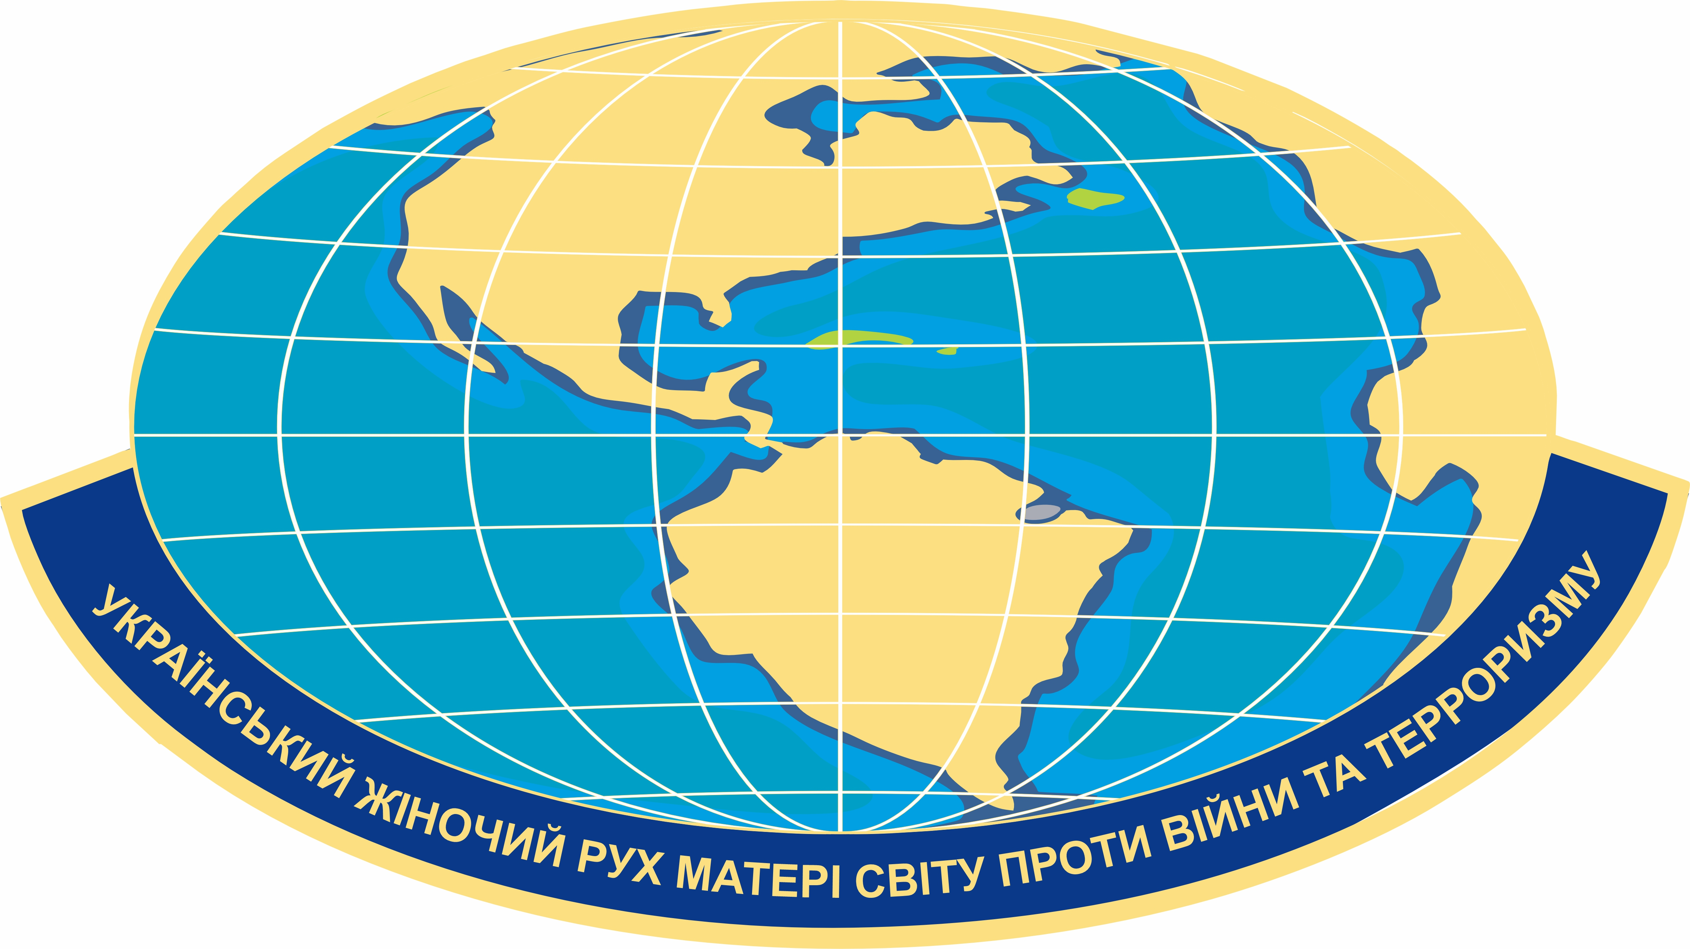 | MOTHER OF THE WORLD UKRAINIAN WOMEN'S MOVEMENT AGAINST WAR AND TERRORISM

р/р - Ua223226690000026006300589972, ЄДРПОУ - 39351325, МФО - 322669
Україна О3О4О м. Київ проспект Голосіївський 87"Л"
www.stolica-ua.com, fondvvv@ukr.net, +38 097-663-47-51 (Viber) +38 050-141-08-76 (WhatsApp)
DECISION OF THE FOUNDERS
No. 1-3/23 dated August 30, 2023

1 TO ESTABLISH A COMMITTEE ON FOREIGN AFFAIRS AND RELATIONS WITH THE GLOBAL DIASPORA.
2 ANNOUNCE THE CREATION OF A COMMITTEE OF LEGISLATIVE INITIATIVES FROM THE MEMBERS OF THE CENTRAL COUNCIL AND APPROVE THE RELEVANT REGULATIONS.
3 Approve the Regulation on the Establishment of the Committee for Legal Assistance in Protecting the Rights of Mothers and Children Forced to Stay Abroad.
4. TO ESTABLISH A COMMITTEE FOR SECURE INFORMATION - UKRAINIAN INTERNATIONAL SERVICE IN 17 COUNTRIES WHERE THE O.KOSYTSY PEOPLE'S CHAPEL WAS IN 1919-25. TO DISTRIBUTE THE BOOK “UKRAINIAN SONG ABROAD”, the world concert tour of the Ukrainian National Choir under the direction of Oleksandr A. Koshytsia, in the Ukrainian language and the language of the country of residence of the Ukrainian diaspora for the population of this country.
5. THE TASK OF THE COMMITTEE FOR THE DISSEMINATION OF HISTORICAL TRUTH IN THE WORLD ABOUT UKRAINE IS TO PROMOTE PEACE AND DEMOCRACY IN THE STRUGGLE AGAINST THE “RUSSIAN WORLD” AND THE RUSSIAN WAR ON THE TERRITORY OF UKRAINE... TO CREATE REPRESENTATIVE OFFICES TO ENSURE MEDIA APPEARANCES AND CULTURAL EVENTS OF THE UKRAINIAN WOMEN'S MOVEMENT IN THE COUNTRY OF RESIDENCE OF THE UKRAINIAN DIASPORA.

6. To create and approve the “Regulations on the establishment of the Order for Peace and Freedom of the Ukrainian-Ukrainian State of Ukraine - Ukrainian Women's Movement ‘Mothers of the World against War and Terrorism’. UKRAINIAN WOMEN'S MOVEMENT “MOTHERS OF THE WORLD AGAINST WAR AND TERRORISM” to be awarded to REPRESENTATIVES OF FOREIGN STATES WHO HELP THE UKRAINIAN PEOPLE DEFEND THEIR STATE OF PEACE AND FREEDOM AND PROTECT OUR LAND FROM WAR CRIMINAL VLADIMIR PUTIN, AS GUARANTEED BY THE SIGNATORIES OF THE BUDAPEST MEMORANDUM IN EXCHANGE FOR THE SURRENDER OF NUCLEAR WEAPONS.
The control over the implementation of the decision and the execution of the relevant documents in accordance with the current legislation is undertaken by the Council of Founders of the Ukrainian Women's Movement “Mothers of the World Against War and Terrorism”
Head of the women's movement
Honored worker of the social sphere of Ukraine
of Social Sphere of Ukraine Valentyna Elias SIGNED on 30.08.23

